ZOHO CRM-WHATSAPP INTEGRATION
Aim - Send automated and whatsapp messages using Zoho CRM data
Business messaging using WhatsApp for Business: Integration with Zoho CRM:
Please check the below documentation
https://help.zoho.com/portal/en/kb/crm/connect-with-customers/business-messaging/articles/business-messaging-using-whatsapp-for-business-integration-with-zoho-crm#Prerequisites
Create a Facebook account using the same number that was used to create WhatsApp.
- Go to Zoho CRM Setup → Channels → Business Messaging and choose WhatsApp
- Click Integrate, log in with your Facebook Business credentials, and follow the screens to link your WhatsApp Business account and number to Zoho CRM.
- After integration, you can start sending WhatsApp messages from CRM
After successful integration, it will appear as “Integrated.” (Please check the screenshot below.)
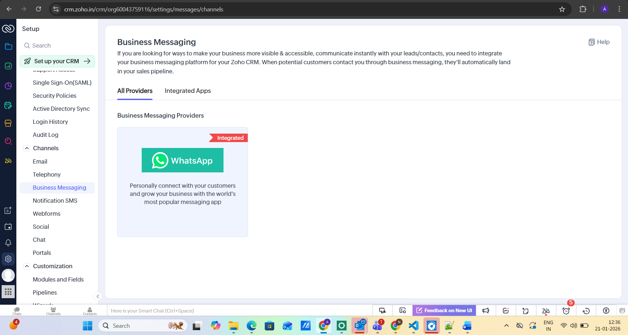
And to check the Whatsapp number, navigate to Integrated Apps
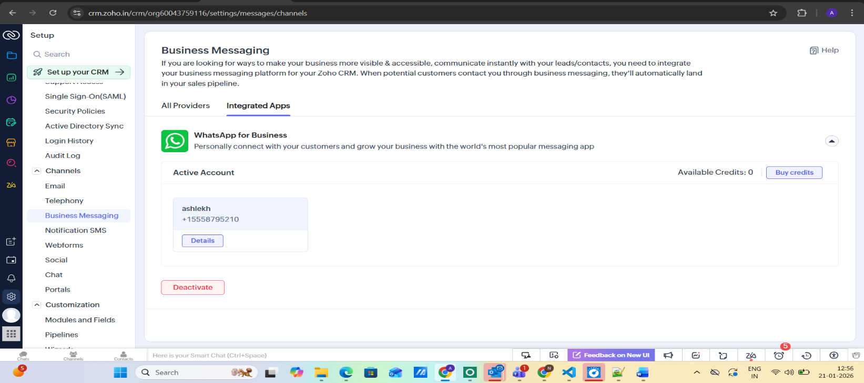

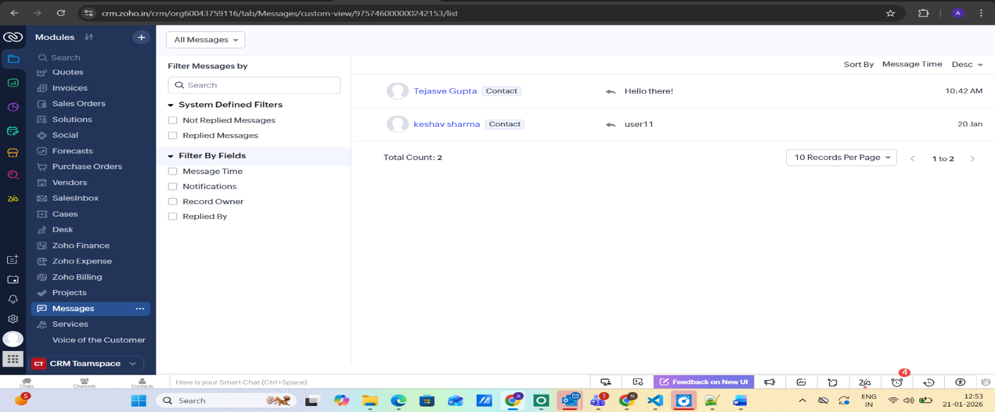
And messages will appear in “Messages” module ( in CRM )

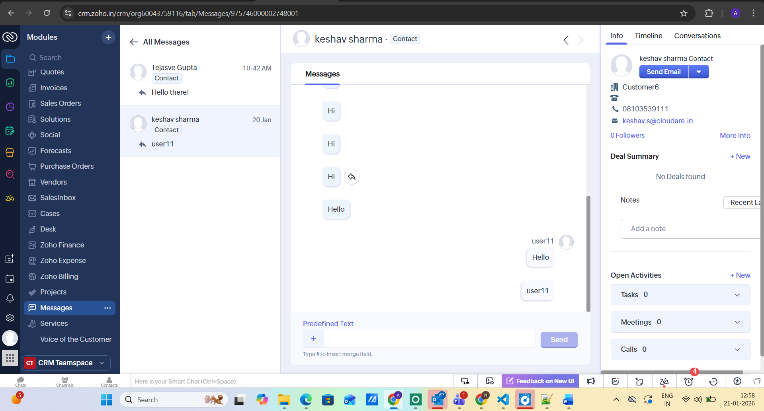
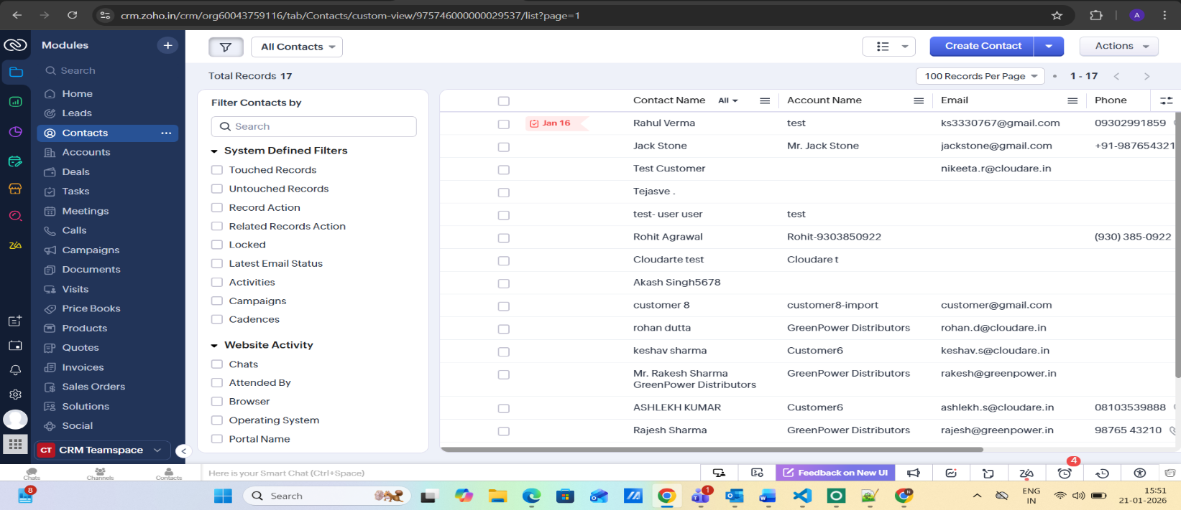
And in records will appear in Contacts tab

We can change the setting so that instead of saving to Contacts, it saves as a Lead. Please refer to below screenshot (click on Details then this popup will open)
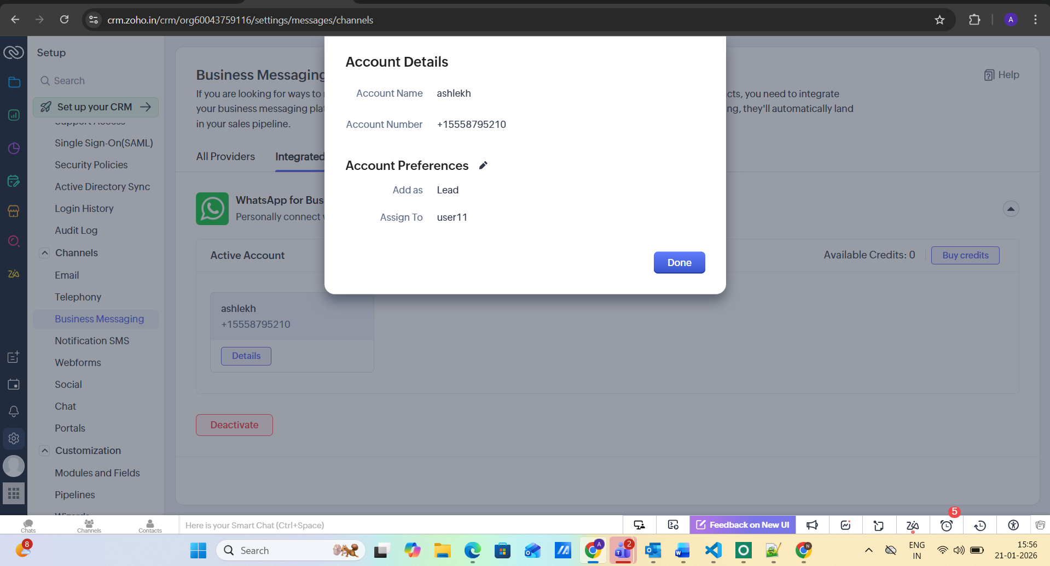
Then after click on Account Preferences
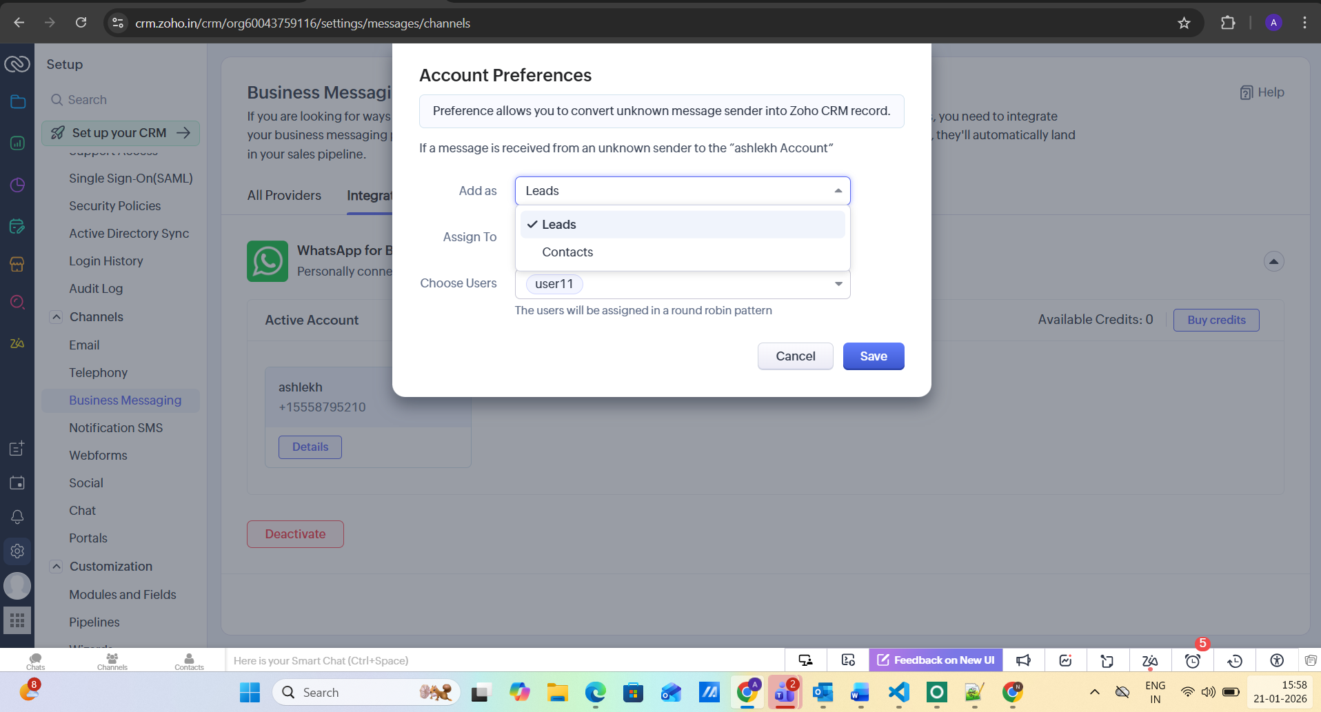
Choose any one Leads or Contacts then Save it.

